1) Table of runs:
Run# | {ia} & service durations distributions | Seed  (6 digit format) | UTIL. Server  %busy | AVE. TIME  avg(cj residence duration) | AVE. TIME  avg(service duration) | MAX  max(number of cj in S) | AVE. CONT  avg(number  of cj in S)
1 | Uniform | 169420 | 76% | 9.350 | 7.488 | 5 | 0.949
2 | Uniform | 420169 | 74.6% | 9.141 | 7.486 | 4 | 0.911
3 | Exponential | Same seed as Run #1 | 73.6% | 27.475 | 7.559 | 28 | 2.675
4 | Exponential | Same seed as Run #2 | 75.8% | 28.573 | 7.484 | 19 | 2.896

2) Report for run #2
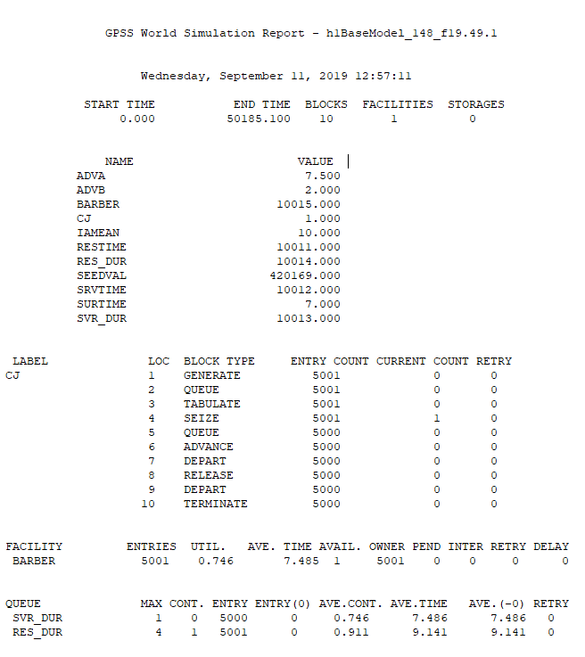

3) A copy of the source code

; The specifications in the following box must be followed for EVERY homework submission.
; This source code has the same gpssW blocks as SAMPLE1.GPS shown in module P1, Slide#6.
; However, this version of SAMPLE1.GPS has the amount/level of documentation that will be
; required in CSC148 assignments.
; +++++++++++++++++++++++++++++++++++++++++++++++++++++++++++++++++++++++++++++++++++++++++++++++
; Preamble documentation for each gpssW model::
; singleBarber FIFO waiting line DES in gpssW; gpssWTutorialManual example, 09-09-2019
; Model time unit (t.u.): 1 clock tick = 1 minute; cj represents customer#j
; Usage: Start a simulation via Command: start n, where n = number of haircuts to complete, 5000 in this case.
; Simulation termination condition: tc becomes 0
; +++++++++++++++++++++++++++++++++++++++++++++++++++++++++++++++++++++++++++++++++++++++++++
; REQUIRED SOURCE line CODING STYLE/LAYOUT: The format of each gpss block/statement MUST BE:
; label(if needed) block/statement Operands(if required) ; Rest of line is a Comment
; The whitespace between code line fields is implemented with tabs.
; EACH source code line must maintain evenly-separated (not ragged) columns
; Source code submissions that do not follow this format are NOT ACCEPTED.
; ++++++++++++++++++++++++++++++++++++++++++++++++++++++++++++++++++++++++++++++++++++++++++++
; The box below is informational concerning DES systems in general
; gpssW uses default seeding that is REPEATED when seed operations are not changed between runs
; => a model computes IDENTICAL results when seeding is the same (if everything else unchanged)
; Warning: seeding rules/behavior are NOT the same for various DES systems in use:
; gpss vs. python/simpy vs. java/simjava, etc.
; ++++++++++++++++++++++++++++++++++++++++++++++++++++++++++++++++++++++++++++++++++++++++++++
clear ; Remove any residual info from previous gpssW runs

; EQU statements to make our life a tad easier
iamean equ 10 ; {ia} mean is 10 minutes
surtime equ 7 ; surtime is 7 minutes

advA equ 7.5 ; advance A is 7.5 minutes
advB equ 2 ; advance B is 2 minutes

seedVal equ 169420 ; set seedVal to some 6-digit value
;seedVal equ 420169 ; set SeedVal to another 6-digit value
rmult seedVal ; seed the SeedVal

; setup our table(s)
restime table q$res_dur,1,1,35 ; create table, with respective tabulate statement below
srvtime qtable svr_dur,1,1,80 ; create another table, does stats largely automatically

; Customer transaction
; Note: this barberShop version names QUEUE and SEIZE operands differently (Is better practice)
cj generate iamean,surtime ; Uniform distribution of cj interarrivals
;cj generate (exponential(1,0,iamean)) ; Exp distribution of cj interarrivals
queue res_dur ; Start stats for cj total service time

tabulate restime ; take note of values entered!
seize barber ; cj waits for busy barber OR starts haircut if barber is free
queue svr_dur ; Start stats for actual service time

advance advA,advB ; Uniform distribution of cj service duration
; advance (exponential(1,0,advA)) ; Exp distribution of cj service dur

depart svr_dur ; End stats for actual service time
release barber ; cj finishes haircut, and barber now free to do next service

depart res_dur ; End stats for cj total service time
terminate 1 ; cj leaves barber shop (Side-effect: tc <-- tc - 1)

4) Histograms for each respective run. A) is number of cj in S, B) is total service time

Run #1
A) cj in S
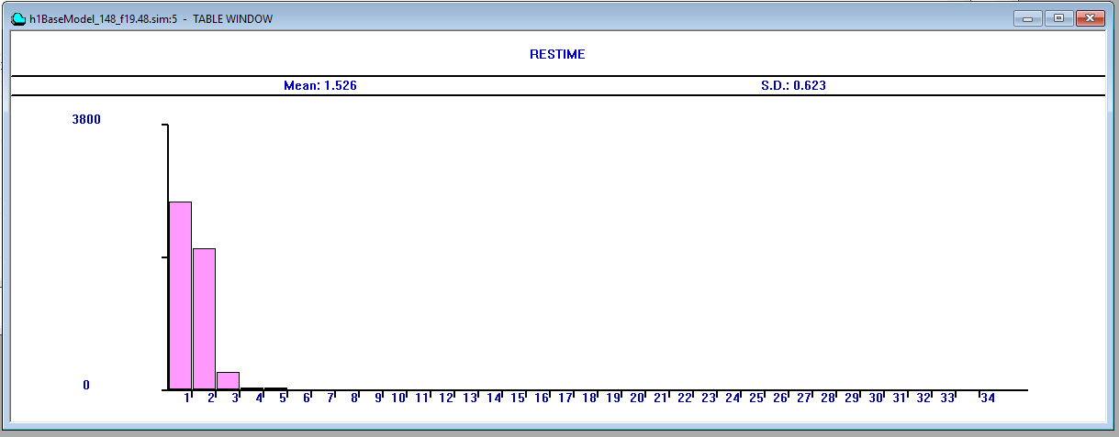
B) service duration
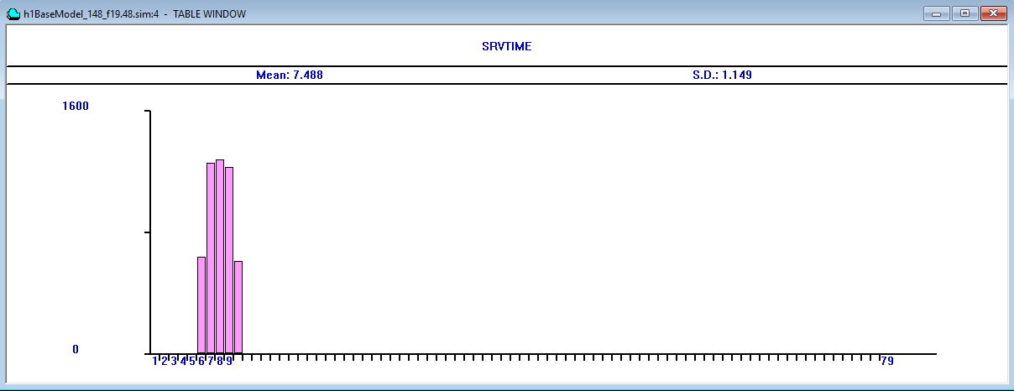

Run #2
A) cj in S
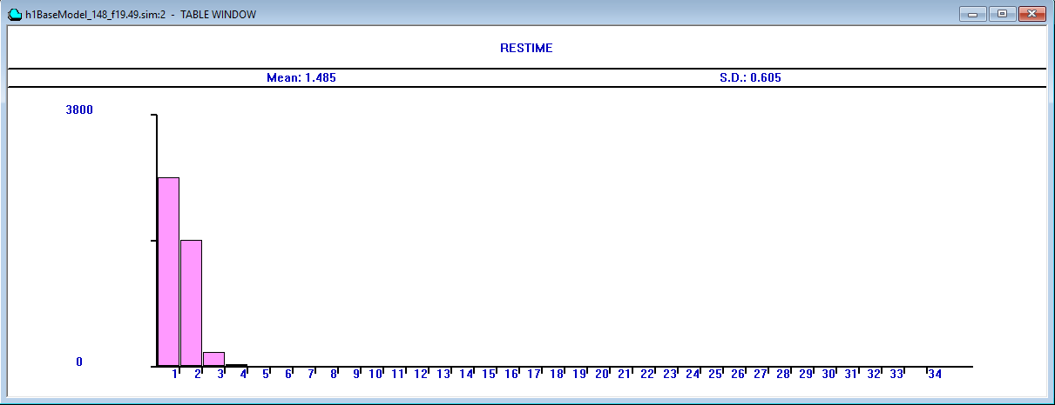
B) service duration
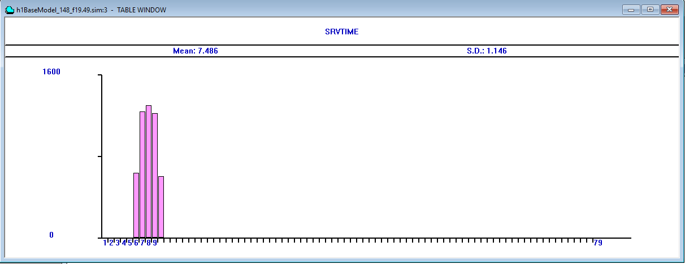

Run #3
A) cj in S
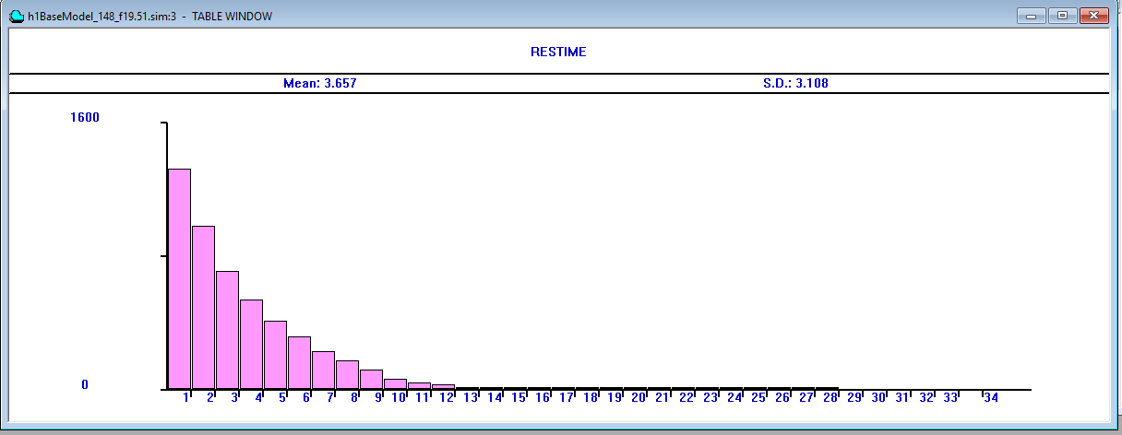
B) service duration
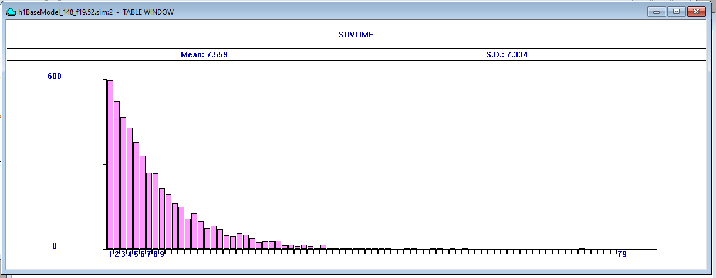

Run #4
A) cj in S
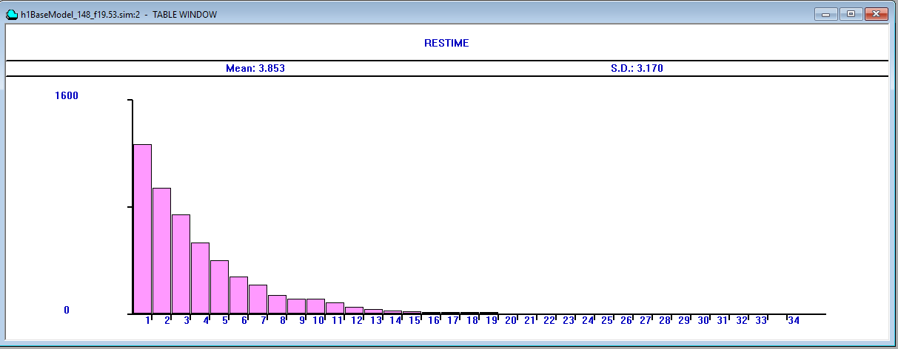
B) service duration
